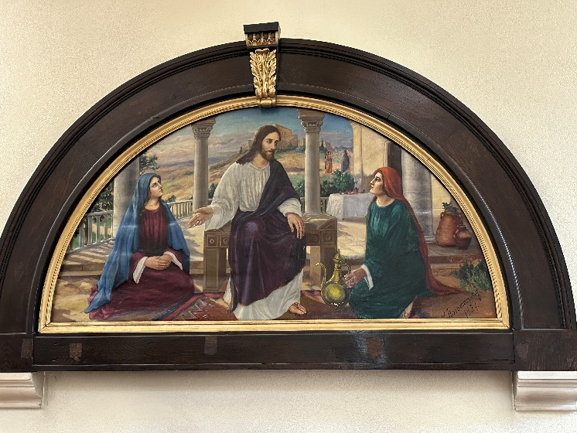

**Wednesday 23rd July**

10am Holy Communion

5pm Evening Prayer

7.30pm **CREDO** -exploring the Christian faith through the creeds continues on Wednesday 23rd July and 6th August

**Thursday 24th July**

10am Pilgrim Bible Study – Genesis 24 – Isaac is born

**Thanks to Semiquavers for a great concert on Tuesday.**

**Thanks to those behind yesterday’s celebration in The Pleasance.**

**HYMN BOOK APPEAL**

Thanks to everyone who has contributed so far – if you are planning to sponsor a hymnbook please pick up a form and return it as soon as possible.

**Cleaner wanted** – we are looking for a reliable cleaner, able to work unsociable hours, for the church hall. If you are interested, or know anyone who might be interested, please speak to Jan or Andrew.

You are invited to Afternoon Tea

in the Vicarage garden in aid of church charities. Sunday 3rd August 4pm-6pm 48 Old Road East

**Monday 4th August**

Volunteering Week – come and lend a hand in the church, hall or grounds. There’s something for everyone to do – summer cleaning, weeding, painting The church and hall will be open from 9am**.** Tea coffee and sausage rolls will be provided. Come for few hours or come for the day.

If you are interested in school admissions please speak to the welcomers, who will register your attendance.

We cannot sign forms unless we have a record of your attendance.

A weekly **children’s sheet** is also available at the door. Please take one if you have someone you would like to pass it on to.

**CHRIST CHURCH**

**Milton next Gravesend**

*a faithfull welcome for all*

**www.christchurchgravesend.org.uk**

Vicar: The Revd Canon Dr Andrew Davey

[vicar@christchurchgravesend.com](mailto:vicar@christchurchgravesend.com)

01474 352643

**20th July 2025**

**5th Sunday after Trinity**

8am Holy Communion

10am Parish Eucharist with God’s Gang followed by refreshments.

12 noon and 1pm Holy Baptism

**THIS MORNING’S HYMNS**

346 Jesus calls us here

590 Seek ye first

115 Come faithful pilgrims all

88 Brother sister let me serve you

412 Lord Jesus think on me

448 meekness and majesty

553 Peace is flowing

**Next Sunday 27th July**

**6th Sunday after Trinity**

8am Holy Communion

10am Parish Eucharist with Baptism (followed by refreshments)

**MORNING PRAYER Tuesday, Thursday and Friday at 8.30am Join us in Church or on ZOOM. The Daily Prayer app can be downloaded on your smart phone.**

https://us02web.zoom.us/j/82117921556

**Please pray for**

The people of Russia and Ukraine, Palestine, Israel, and Iran

Holy Family church in Gaza

Those who work in diplomacy and peace making

The children baptised today

Those choosing the new Archbishop of Canterbury

The children in our church – God’s Gang, our preschool, Tots, Semiquavers and First Steps, and our uniformed groups

Please remember those who have died, especially Janet Dunlop, Evelyn Wisdom, Peter Willis and those who mourn.

Remember in addition to the collection plate you can give to the Church using the card reader or online you will find our giving page using this QR code.