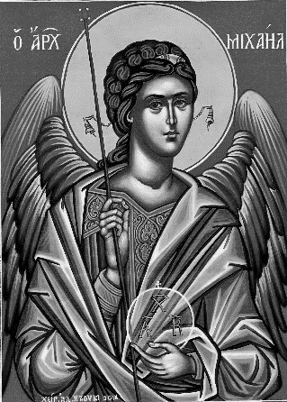

**Thanks to everyone who helped with yesterday’s table top sale.**

**Alex raised £755 for** Ellenor on his Twilight Walk in memory of Ted Barden. Well done, Alex.

**Wednesday 2nd October** 7.45pm Parochial Church Council

**Friday 4th October 1.30pm** Christ Church Tots – play in the hall

**Tuesday 8th October**

7.30pm Mothers’ Union Film Evening

**Sunday 13th October HARVEST**

We will be collecting for the Daily Hub Food Bank on Saturday and Sunday morning. A list of requirements is available at the back of the church.

10am Harvest Festival Eucharist

4pm Harvest Tea – please sign up – also please let us know if you are able to bring food to share (see list).

6pm Harvest Evensong

**Saturday 12th and Sunday 13th from 12pm-4 pm**

**Harvest Home** – Gravesend Flower Arrangers annual show in church.

**Christmas Bazaar Saturday 9th November**

Please start turning out your cupboards and drawers for things we can sell at our Bazaar.

There will be boxes at the back of the church from next Sunday 6th October or see one of us to arrange to put donations straight into the shed. We are unable to store donations in church until after the Harvest Flower Show.

Please remember to put your used HP Ink cartridges in Pr. Jacqueline’s box at the back of the church.

If you are interested in school admissions please speak to the welcomers who will register your attendance.

We cannot sign forms unless we have a record of your attendance.

A weekly **children’s sheet** is also available at the door. Please take one if you have someone you would like to pass it on to.

Remember in addition to the collection plate you can give to the Church using the card reader or online - you will find our giving page using this QR code.

**CHRIST CHURCH**

**Milton-next-Gravesend**

*a faith-full welcome for all*

**www.christchurchgravesend.org.uk**

Vicar: The Revd Dr Andrew Davey

[vicar@christchurchgravesend.com](mailto:vicar@christchurchgravesend.com)

01474 352643

**29th September 2024**

*St Michael and All Angels*

8am Holy Communion

10am Parish Eucharist (followed by refreshments)

**THIS MORNING’S HYMNS**

37 Angel Voices ever singing

314 Immortal Invisible

534 O Praise ye the Lord

74 Blessed Assurance

41 Around the throne of God Above

762 You are the King of Glory

296 How shall I sing that Majesty

**Wednesday 2nd October**

10am Holy Communion

**Next Sunday 6th October**

**Nineteenth Sunday after Trinity**

8am Holy Communion

10am Parish Eucharist with God’s Gang

(followed by refreshments)

**MORNING PRAYER Join us in church or on zoom at 8.30am on Tuesday, Thursday or Friday (not Monday)**

[**https://us02web.zoom.us/j/82117921556**](https://us02web.zoom.us/j/82117921556)

**Please pray for**

The people of Palestine, Israel, Syria and Lebanon, Ukraine and Russia – for the United Nations

The people and churches of Jerusalem

Andrew, as he acquires his new responsibilities

Those affected by violence

The Foodbank and Daytime Hub

Those returning to or beginning preschool and school.

Please remember those who have died recently, especially Derek Bodle, John Moxham and Eric Porter and those who mourn.