Thank you to everyone who has helped make our Holy Week and Easter so special.

Please return your Lent Appeal envelopes.

Tuesday 9th April
7.30pm Mothers Union: Mary’s Meals
Wednesday 10th April
2pm First Steps service
Saturday 13th April
From 9.30am Working morning
Friday 5th April we have been invited to the Iftar (the breaking of the Ramadan fast) at Gravesend Mosque 11 Albion Terrace. Let Andrew know if you would like to come.
Friday 5th April 11:45am Eid flag raising on Community Square
Saturday 6th April 11am Vaisaki flag raising on Community Square
Saturday 6th April 9:30-10:30am full English breakfast at St Peter and St Paul, Milton. Please make a donation for your breakfast in the collection box and the charity being supported for April is Water Aid.
If you are part of the weekly offering envelope scheme, then you will find your new set of envelopes, beginning on 7th April 2024, waiting for you at the back of church. Please take yours. We have a few spare sets, so if anyone would like to commit to regular giving in this way please speak to Anne Thrush.
Memorial services
Wednesday 10th April 10am Barbara Bunyan
Saturday 20th April 12noon Margaret Davies
Remember in addition to the collection plate you can give to the Church using the card reader or online - you will find our giving page using this QR code.
If you are interested in school admissions please speak to the welcomers who will register your attendance.
We cannot sign forms unless we have a record of your attendance.
A weekly children’s sheet is also available at the door. Please take one if you have someone you would like to pass it on to.

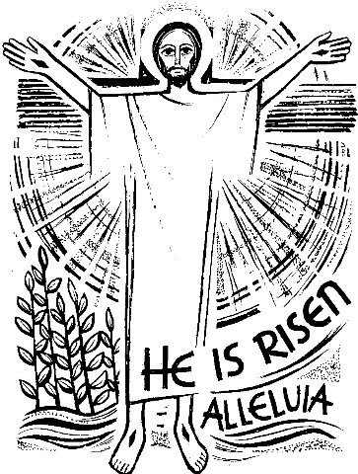

CHRIST CHURCH
Milton-next-Gravesend
a faith-full welcome for all

www.christchurchgravesend.org.uk
Vicar: The Revd Dr Andrew Davey
vicar@christchurchgravesend.com
01474 352643

31st March 2024
Easter Day
6am Dawn Service
8am Holy Communion BCP
10am Parish Eucharist with baptisms (followed by refreshments) We will be admitting three of our young people to communion during the service
6pm Evensong

TODAYS MORNING’S HYMNS
Dawn
754 Ye choirs of New Jerusalem
198 From the depths of darkness v 1,2,6

10am Hymns in service book
Light’s glittering dawn
Jesus Christ is ris’n today
Awake Awake
Alleluia Alleluia hearts to heaven
Communion:
The strife is o’er, He is Lord, Alleluia give thanks
Thine be the glory

Evensong
103 Christ the Lord
475 Now the green blade
637 The day of resurrection

Wednesday 10am Holy Communion

Next Sunday 7th April
Second Sunday of Easter
8am Holy Communion
10am Parish Eucharist with God’s Gang (followed by refreshments)
12noon and 1pm Baptisms

MORNING PRAYER will resume on Monday 8th April

Please pray for
Those who will be baptised and admitted to communion today
The people of Palestine and Israel, Sudan, Nigeria and Haiti
Those held hostage
The people and churches of Jerusalem
All who have suffered acts of violence and accidents
Please remember those who have died recently and those who mourn.

