**Thanks to those who helped with yesterday’s working morning.**

**This afternoon 4pm Baptism, Confirmation and Eucharist** at St Aidan’s – please come and support Shannia

**Wednesday 17th September**

10am Holy Communion

5pm Evening Prayer

7.45pm PCC Meeting

**Thursday 18th September**

2.30pm Mustard Seed – tea, cake, chat and good company

**Saturday 20th September 12 noon Holy Matrimony**

**Thursday 25th September 10 am Pilgrim Bible Study in the choir vestry** Genesis 23 Burying Sarah – buying the promised land

**Alex will be taking** part in the Ellenor Twilight Walk in memory of Ted Barden. There is a form at the back of the church if you would like to sponsor him.

**Ann Russell’s funeral** will be at Christ Church on Tuesday 23rd September at 2pm followed by 3pm at Thamesview Crematorium. Please let the Vicar know, today, if you would like to attention the reception afterwards.

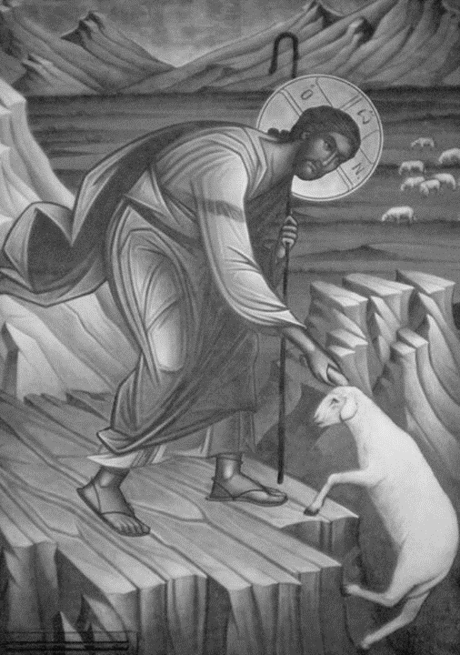**CHRIST CHURCH**

**Milton next Gravesend**

*a faithfull welcome for all*

**www.christchurchgravesend.org.uk**

Vicar: The Revd Canon Dr Andrew Davey

[vicar@christchurchgravesend.com](mailto:vicar@christchurchgravesend.com)

01474 352643

**14th September 2025**

**13th Sunday after Trinity**

8am Holy Communion

10am Parish Eucharist followed by refreshments.

**THIS MORNING’S HYMNS**

565 Praise my soul

29 Amazing Grace

310 I heard the voice of Jesus

156 Faithful shepherd

726 We will lay our burden down

323 In heavenly love

572 Praise to the holiest

**Next Sunday 21th September**

**14th Sunday after Trinity**

8am Holy Communion

10am Parish Eucharist with God’s Gang (followed by refreshments)

12noon and 1pm Holy Baptism

**MORNING PRAYER Tuesday, Thursday and Friday at 8.30am Join us in Church or on ZOOM. The Daily Prayer app can be downloaded on your smart phone.**

https://us02web.zoom.us/j/82117921556

**Please pray for**

The people of Russia and Ukraine, Palestine and Israel

Those who are hungry and those who distribute food

All Christians in the Holy Lands

Those who work in diplomacy and peace making

Those forced to seek asylum because of need, war, and persecution.

Those preparing for marriage

Those being baptised and confirmed this afternoon

Those choosing the new Archbishop of Canterbury

If you are interested in school admissions please speak to the welcomers, who will register your attendance.

We cannot sign forms unless we have a record of your attendance.

**School forms will be signed on Friday 19th September between 6pm and 6.45pm**

A weekly **children’s sheet** is also available at the door. Please take one if you have someone you would like to pass it on to.

Those starting new courses or jobs

Please remember those who have died, particularly Ann Russell, and those who mourn.

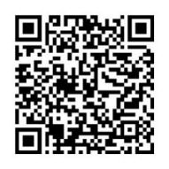Remember in addition to the collection plate you can give to the Church using the card reader or online you will find our giving page using this QR code.