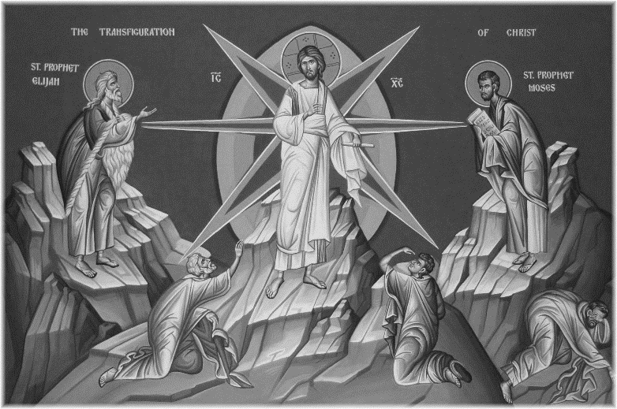
Thanks to everyone who helped with yesterday’s Table Top sale.

When your child goes to God’s Gang please tell the leaders if he/she has any allergies

Tuesday 17th February
PANCAKES at the Vicarage on Shrove Tuesday 17th February 4pm to 6pm
Come and enjoy pancakes at 48 Old Road East.

Wednesday 18th February
10am Holy Communion (BCP) with imposition
of ashes
5pm Evening Prayer
8pm Holy Eucharist with imposition of ashes

Christian Aid Bread and Cheese Lunch in St. George’s Church Hall on Ash Wednesday 18th February from 12.15 – 1.45 pm. £3. Homemade stall.

Thursday 19th February
2.30pm Mustard Seed – tea, cake, chat and
good company. Everyone welcome.

Saturday 21st February from 9.30 am Church working party. Please come along and lend a hand.

Tell me another – reading the parables in Matthew’s Gospel Our Lent study groups will start in the week beginning 22nd February. As usual there will be two opportunities in each week – on Mondays at 7.30pm and Thursday at 10am both in the choir vestry – come through the small door of the church. Our Lent Study Groups are an exciting way to go deeper in our faith and engage with each other. Come and join us.
If you are interested in school admissions please speak to the welcomers, who will register your attendance.
We cannot sign forms unless we have a record of your attendance.

A weekly children’s sheet is also available at the door. Please take one if you have someone you would like to pass it on to.

CHRIST CHURCH
Milton next Gravesend
a faithfull welcome for all

www.christchurchgravesend.org.uk
Vicar: The Revd Canon Dr Andrew Davey
vicar@christchurchgravesend.com
01474 352643

15th February
Last Sunday before Lent
Quinquagesima
8am Holy Communion
10am Parish Eucharist with God’s Gang followed by refreshments

THIS MORNING’S HYMNS
291 parts 2 & 3 Christ is made
279 Jesus on the mountain peak
2 Christ whose glory
712 Lord Jesus Christ
467 The Son of God proclaim
463 Strengthen for service
719 Lord the light of your love

Next Sunday 22nd February
First Sunday of Lent
8am Holy Communion
10am Parish Eucharist followed by refreshments.

MORNING PRAYER Tuesday, Thursday and Friday at 8.30am. Join us in church or on ZOOM. https://us02web.zoom.us/j/82117921556
The Daily Prayer app can be downloaded on your smart phone.

Please pray for
Sarah Mullally, our new archbishop
Those who work in diplomacy, aid and peace making
The people of Russia and Ukraine, Palestine and Israel, Iran
Our 2026 charities: Elliot Holmes, Mission to Seafarers, St Christopher’s and Mary’s Meals
Those experiencing extreme weather and its consequences
Those who are the victims of hatred and violence
The children in our church – Semiquavers, Tots, First Steps, God’s Gang and our preschool
Please remember those who have died and those who mourn.


Remember in addition to the collection plate you can give to the Church using the card reader or online you will find our giving page using this QR code.

