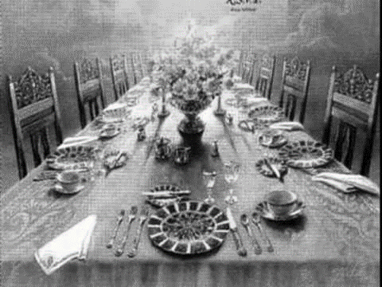

**Wednesday 3rd September**

10am Holy Communion

**Last Night of the Proms, Saturday 13th September** 7.30pm arrival. Food £10 per head, will arrive at 8 pm. Book in advance with Angela by calling 07900430002 before 10th September and let her know if you would like fish, sausage, chicken strips or vegeburger with your chips. BYO Drinks.

**Kent Churches Ride and Stride on Saturday 13th September between 10 am and 6 pm.**  Sponsor forms are at the back of the church. Please speak to Pr. Jacqueline If you would like more information.

David Williams will be taking part in Ride and Stride. There is a sponsor form at the back of the church or have a word with David.

**Tuesday 9th September 7.30pm Mothers Union**

Donna Sellick from ‘Busyblooms’

**Sunday 14th September 4pm Confirmation at St Aidan’s**

**Alex will be taking** part in the Ellenor Twilight Walk in memory of Ted Barden. There is a form at the back of the church if you would like to sponsor him.

**Gravesend Flower Arrangers** have a demonstration from Robin White on Wednesday 10th September to celebrate 65 years of the club. 6.30 for 7pm – cake and fizz – visitors £7.

**Wednesday 3rd September** Merchant Navy Day Service

11 am at Anchor Cove, Bawley Bay. Everyone welcome to attend.

**CHRIST CHURCH**

**Milton next Gravesend**

*a faithfull welcome for all*

**www.christchurchgravesend.org.uk**

Vicar: The Revd Canon Dr Andrew Davey

[vicar@christchurchgravesend.com](mailto:vicar@christchurchgravesend.com)

01474 352643

**31st August 2025**

**11th Sunday after Trinity**

8am Holy Communion

10am Parish Eucharist followed by refreshments.

**THIS MORNING’S HYMNS**

105 Christ whose glory

691 Thy kingdom come O God

662 There’s a wideness

68 Be still my soul

738 When I survey

733 When God almighty

736 When I needed a neighbour

**Next Sunday 7th September**

**12th Sunday after Trinity**

8am Holy Communion

10am Parish Eucharist (followed by refreshments)

**MORNING PRAYER Monday, Tuesday, Thursday and Friday at 8.30am Join us in Church or on ZOOM. The Daily Prayer app can be downloaded on your smart phone.**

https://us02web.zoom.us/j/82117921556

**Please pray for**

The people of Russia and Ukraine, Palestine, Israel, and Iran

Those who are hungry and those who distribute food

All Christians in the Holy Lands

Those who work in diplomacy and peace making

Those forced to seek asylum because of need, war, and persecution.

All starting at a new term and new schools

Those choosing the new Archbishop of Canterbury

The children in our church – God’s Gang, our preschool, Tots, Semiquavers and First Steps, and our uniformed groups

If you are interested in school admissions please speak to the welcomers, who will register your attendance.

We cannot sign forms unless we have a record of your attendance.

**School forms will be signed on Friday 19th September between 6pm and 6.45pm**

A weekly **children’s sheet** is also available at the door. Please take one if you have someone you would like to pass it on to.

Please remember those who have died, particularly Jim Haselden, Archie Coyle, Sylvia Wise, Barry Cross and Ann Russell, and those who mourn.

Remember in addition to the collection plate you can give to the Church using the card reader or online you will find our giving page using this QR code.