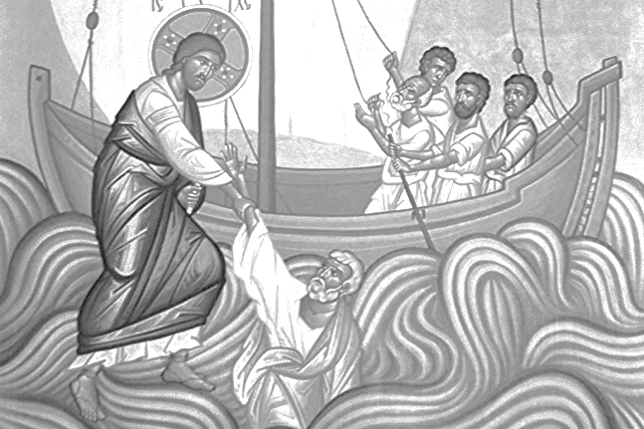

Thanks to everyone who came and helped with tasks around the church and grounds this week.

Wednesday 12th August
10am Holy Communion
2pm First Steps with Teddy Bears Picnic – all preschoolers welcome

Christ Church Mothers’ Union invite you to join us for a celebratory T@3 on Wednesday 19th August - 3.00 pm in the church hall. Entrance for adults £2 - children free. Cakes, drinks, raffles, quizzes, bring and buy. We shall be dedicating our MU bench at 4.00 pm. Please do come along and support us on this special occasion. Everyone is welcome.

Please help families who are struggling this summer. Don’t forget our Foodbank collection – donations can be put in the bags in the porch.

The funeral service for John Boucher will be on Thursday 20th August at 10.30am
The services for Marian Shearan will be on Friday 28th August. 1pm Thamesview Crematorium, 2pm at Christ Church.

Alex will be taking part in the 7.5km Ellenor Twilight Walk on Friday 18th September to raise funds in memory of Ted Barden. There are sponsor forms at the back of the church if you would like to sponsor him.

Remember in addition to the collection plate you can give to the Church online- you will find our giving page using this QR code.
If you are interested in school admissions please speak to the welcomers who will register your attendance.
We cannot sign forms unless we have a record of your attendance.

A weekly children’s sheet is also available at the door. Please take one if you have someone you would like to pass it on to.
CHRIST CHURCH
Milton-next-Gravesend
a faith-full welcome for all

www.christchurchgravesend.org.uk
Vicar: The Revd Canon Dr Andrew Davey
vicar@christchurchgravesend.com
01474 352643

9th August 2026

TENTH SUNDAY AFTER TRINITY

8am Holy Communion
10am Parish Eucharist (followed by refreshments)

THIS MORNING’S HYMNS
676 Immortal invisible
738 Not far beyond
748 O Jesus I have promised
330 Do not be afraid
464 Sweet sacrament
566 Put peace into
629 Father hear the prayer we offer
Next Sunday
16th August ELEVENTH SUNDAY AFTER TRINITY
8am Holy Communion
10am Parish Eucharist (followed by refreshments)

MORNING PRAYER will resume on Monday 7th September at 8.30am.

Please pray for
All forced to flee their home because of war, violence, natural disaster and climate change
Iran, USA, Sudan, Lebanon, Ukraine and Russia, Palestine and Israel
Those who work in diplomacy and peace making
Those impacted by fires in Suffolk, Greece, France and Spain
Those waiting for exam results
Those who will find the school holidays difficult
All affected by the hot weather
The Foodbank, the Daytime Hub and those who use them
Please remember those who have died recently particularly, John Boucher, Marian Shearan and those who mourn.

