**Sunday 13th October HARVEST**

We will be collecting for the Daytime Hub Food Bank

10am Harvest Festival Eucharist

4pm Harvest Tea –

6pm Harvest Evensong

**Sunday 13th from 12pm-4 pm**

**Harvest Home** – Gravesend Flower Arrangers annual show in church continues.

**Scaffolding** will arrive in church on Monday morning to enable our tower walls repair. This will be in place for probably 4 weeks. Please take care around the scaffolding. – we hope things will be as ‘normal’ as possible.

**Christian Aid Soupa Meal on Wednesday 16th October in St. George’s Church Hall from 12.15 to** **1.45 pm.** £3. Homemade Stall. All welcome.

**Friday 18th October 1.30pm** Christ Church Tots – play in the hall

**The next working party will be on Saturday 19th October starting at 9.30 pm.** Please come along and give a hand.

**Thursday 24th October 10 am** Pilgrim Bible Study

Genesis 4 “in the family”

**Our Shoebox Appeal** is running. Time is passing very fast and **3rd November** is not far away. There are decorated shoeboxes at the back of the church, please take one and fill it – we need your help. Veronica.

**Christmas Bazaar Saturday 9th November**

Please start turning out your cupboards and drawers for things we can sell at our Bazaar.

There will be boxes at the back of the church from next Sunday 6th October or see one of us to arrange to put donations straight into the shed. We are unable to store donations in church until after the Harvest Flower Show.

Please remember to put your used HP Ink cartridges in Pr. Jacqueline’s box at the back of the church.

Remember in addition to the collection plate you can give to the Church using the card reader or online you will find our giving page using this QR code.

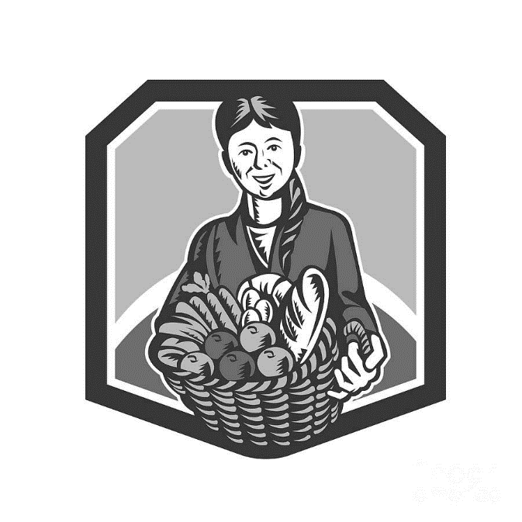

**CHRIST CHURCH**

**Milton next Gravesend**

*a faithfull welcome for all*

**www.christchurchgravesend.org.uk**

Vicar: The Revd Dr Andrew Davey

[vicar@christchurchgravesend.com](mailto:vicar@christchurchgravesend.com)

01474 352643

**13th October 2024**

*Twentieth Sunday after Trinity*

*HARVEST*

8am Holy Communion

10am Harvest Eucharist (followed by refreshments)

6pm Harvest Evensong

**THIS MORNING’S HYMNS**

719 We plough the fields

558 Praise and Thanksgiving

559 Praise God for the harvest

185 For the fruits of all creation

926 Eat this bread drink this cup

563 Praise him praise him

172 Fill your hearts

**Wednesday 16th October**

10am Holy Communion

5pm Evening Prayer

**Next Sunday 20th October**

**Twenty first Sunday after Trinity**

8am Holy Communion

10am Parish Eucharist with God’s Gang (followed by refreshments)

12 noon and 1pm Holy Baptism

**MORNING PRAYER will be paused this week.**

**Please pray for**

The people of Palestine, Israel, Syria, Iran and Lebanon, Ukraine and Russia – for the United Nations

The people and churches of Jerusalem

Those affected by violence

Those suffering extreme weather

All involved in the production and distribution of food

The Foodbank and Daytime Hub

Please remember those who have died recently, especially Vena Croydon, Doreen Dillon, Derek Bodle, John Moxham and Eric Porter and those who mourn.

If you are interested in school admissions please speak to the welcomers who will register your attendance.

We cannot sign forms unless we have a record of your attendance.

A weekly **children’s sheet** is also available at the door. Please take one if you have someone you would like to pass it on to.