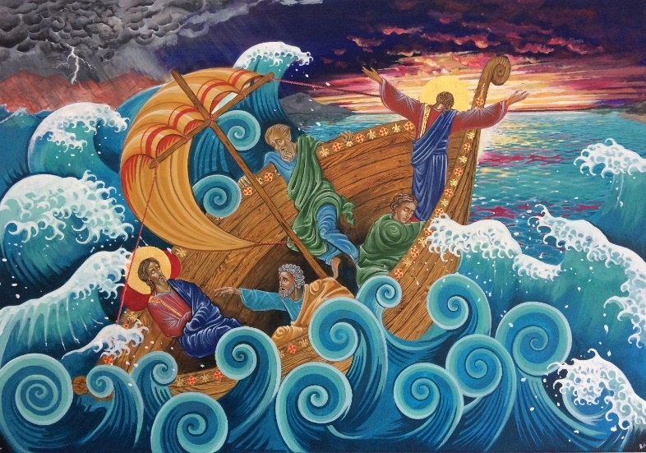

**Wednesday 26th February**

10am Holy Communion

5pm Evening Prayer

**Thursday 27th February**

10am Pilgrim Group Genesis 15.1-21 A covenant with Abraham

**PALM CROSS AMNESTY**

We need your palm crosses. As we approach Ash Wednesday we are inviting people to bring their palm crosses from previous years back to church. These will be burnt to make the ash we will use to mark the beginning of Lent. Please place your crosses in the basket by the door.

**Tuesday 4rd March Shrove Tuesday**

4pm to 6pm Pancakes at the Vicarage

**Wednesday 5th March Ash Wednesday**

10am Holy Communion (BCP) with imposition of Ashes

12.15pm Christian Aid Bread and Cheese Lunch in St George’s Church Hall. £3. Homemade stall.

8pm Parish Eucharist with imposition of ashes

**Friday 7th March at 10.30 am** World Day of Prayer Service in the Salvation Army Citadel, The Grove. All welcome

Lent study starts week beginning 10th March

The Mothers’ Union will be holding a Simnel Cake raffle. Tickets £1.50. To be drawn on Mothering Sunday.

Remember in addition to the collection

plate you can give to the Church using

the card reader or online you will find

our giving page using this QR code.

**CHRIST CHURCH**

**Milton next Gravesend**

*a faithfull welcome for all*

**www.christchurchgravesend.org.uk**

Vicar: The Revd Dr Andrew Davey

[vicar@christchurchgravesend.com](mailto:vicar@christchurchgravesend.com)

01474 352643

**23rd February 2025**

**Second Sunday before Lent Sexagesima**

8am Holy Communion

10am Parish Eucharist (followed by refreshments)

**THIS MORNING’S HYMNS**

314 Immortal invisible

437 - Make me a channel

625 - Take my life

411 - Lord Jesus Christ

924 - Calm me Lord

153 - Eternal father strong to save

19 - All my hope

**Next Sunday 2nd March**

**Last Sunday before Lent Quinquagesima**

8am Holy Communion

10am Parish Eucharist with God’s Gang followed by refreshments

**MORNING PRAYER Join us in church or on zoom at 8.30am on Monday, Tuesday, Thursday and Friday**

[**https://us02web.zoom.us/j/82117921556**](https://us02web.zoom.us/j/82117921556)

**Please pray for**

The people of Palestine, Israel and Lebanon, Syria, Ukraine and Russia, DR Congo – for the United Nations

Our government and those responsible for foreign affairs

The work of Christian Aid

Those forced to flee their homes because of persecution, hardship or war

Those who work on the river and the sea, RNLI

Our councillors and MP

Sandra, our new Archdeacon, who will be installed this afternoon

If you are interested in school admissions please speak to the welcomers, who will register your attendance.

We cannot sign forms unless we have a record of your attendance.

A weekly **children’s sheet** is also available at the door. Please take one if you have someone you would like to pass it on to.

Pope Francis

Please remember those who have died recently especially Christine Elander, Jean Griggs and those who mourn.