**Wednesday 2nd July**

10am Holy Communion

5pm Evening Prayer

7.30pm Credo Group – exploring the Christian faith in the creeds

**Friday 4th July 1.30pm** Christ Church Tots

**Tuesday 8th 7.30 pm** Mothers’ Union

**Wednesday 9th July 2.00pm**  First Steps Service

**Thursday 10th July** 10am Pilgrim Bible Study Group

**Saturday 11th July 9.30 pm** Working morning around the church and grounds

**Sunday 13th July 10am**

‘End of Term’ Parish Eucharist with Semiquavers

6pm Choral Evensong for Sea Sunday

**Cleaner wanted** – we are looking for a reliable cleaner, able to work unsociable hours, for the church hall. If you are interested, or know anyone who might be interested, please speak to Jan or Andrew.

**CHRIST CHURCH SUMMER PARTY**

**An evening on the Pleasance – Saturday 19th July**

£10 per adult £5 per child

Includes a glass of Pimms/Bucks Fizz

or orange juice on arrival

Miss Vintage will be performing

Arrive from 5.00 pm

Bring your own picnic

If you are interested in school admissions please speak to the welcomers, who will register your attendance.

We cannot sign forms unless we have a record of your attendance.

A weekly **children’s sheet** is also available at the door. Please take one if you have someone you would like to pass it on to.

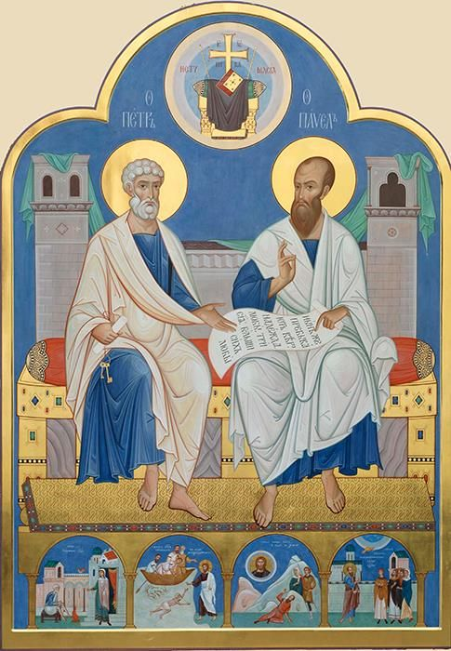

**CHRIST CHURCH**

**Milton next Gravesend**

*a faithfull welcome for all*

**www.christchurchgravesend.org.uk**

Vicar: The Revd Canon Dr Andrew Davey

[vicar@christchurchgravesend.com](mailto:vicar@christchurchgravesend.com)

01474 352643

**29th June 2025**

**2nd  Sunday after Trinity/ St Peter & St Paul**

8am Holy Communion

10am Parish Eucharist (followed by refreshments)

**THIS MORNING’S HYMNS**

636 The church’s one foundation

437 Make me a channel

411 Lord Jesus Christ

212 God forgave my sin

350 Jesus good above all others

752 Will you come and follow me

**Next Sunday 6th July**

**3rd Sunday after Trinity**

8am Holy Communion

10am Parish Eucharist with God’s Gang followed by refreshments. Preacher: The Ven Sandra McCalla, Archdeacon of Rochester

**MORNING PRAYER Monday, Tuesday, Thursday and Friday at 8.30am Join us in Church or on ZOOM. The Daily Prayer app can be downloaded on your smart phone.**

https://us02web.zoom.us/j/82117921556

**Please pray for**

The people of Russia and Ukraine, Palestine, Israel, and Iran, the Democratic Republic of the Congo.,

Those who work in diplomacy and peace making

Our armed services and their chaplains

All being ordained at Petertide

Those choosing the new Archbishop of Canterbury

The children in our church – God’s Gang, our preschool, Tots and First Steps, and our uniformed groups

Please remember those who have died, especially Monica Hayden, Janet Dunlop, Evelyn Wisdom, Peter Willis and Cynthia Whiteford, and those who mourn.

Remember in addition to the collection plate you can give to the Church using the card reader or online you will find our giving page using this QR code.