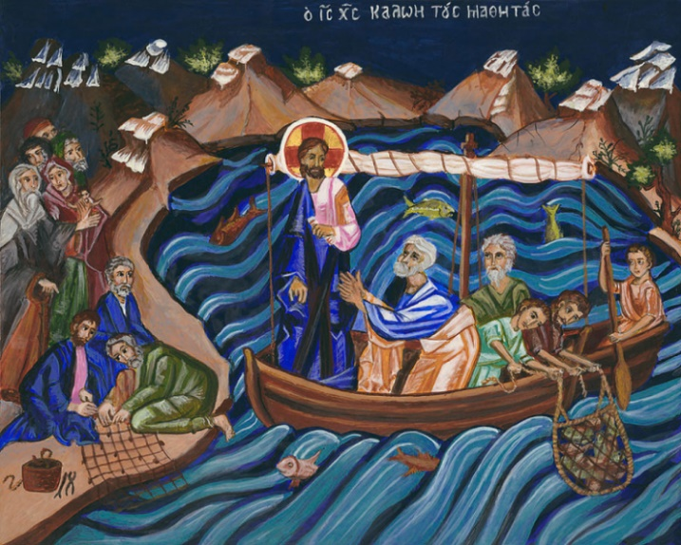

**Tuesday 11th February**

7.30pm Mothers’ Union AGM

Jacqueline will leading us in Holy Communion prior to the start of the meeting. Non members are welcome - why not come along and see what we are all about.

**Wednesday 12th February**

10am Holy Communion

2pm First Steps service. If you are a family with pre-school children, please come and join in the fun.

5pm Evening Prayer

**Thursday 13th February**

10am Pilgrim Bible Study: Genesis 13 Wandering with Abraham

**Friday 14th February**

9am Funeral of Pat Arnott at Thamesview

Crematorium

1.30pm Tots group in Church Hall

**Thursday 20th February**

2.30-4pm Mustard Seed

Remember in addition to the collection

plate you can give to the Church using

the card reader or online you will find

our giving page using this QR code.

If you are interested in school admissions please speak to the welcomers, who will register your attendance.

We cannot sign forms unless we have a record of your attendance.

A weekly **children’s sheet** is also available at the door. Please take one if you have someone you would like to pass it on to.

**CHRIST CHURCH**

**Milton next Gravesend**

*a faithfull welcome for all*

**www.christchurchgravesend.org.uk**

Vicar: The Revd Dr Andrew Davey

[vicar@christchurchgravesend.com](mailto:vicar@christchurchgravesend.com)

01474 352643

**9th February 2025**

**Fourth Sunday before Lent**

8am Holy Communion

10am Parish Eucharist

(followed by refreshments)

**THIS MORNING’S HYMNS**

286 Holy holy holy

590 Seek ye first

733 When God almighty came to earth

619 Strengthen for service

366 Jesus took a piece of bread

35 A new commandment

409 Lord for the years

**Next Sunday 16th February**

**Third Sunday before Lent Septuagesima**

8am Holy Communion

10am Parish Eucharist with God’s Gang (followed by refreshments) There will be prayers for healing and wholeness offered after communion.

**MORNING PRAYER will resume at 8.30am on Monday 17th February**

**Please pray for**

The General Synod meeting in London and the leadership of the Church of England

Our Mothers’ Union branch

The people of Palestine, Israel and Lebanon, Syria, Ukraine and Russia, Darfur – for the United Nations

All affected by acts of violence

The people and churches of the Middle East

All who struggle for racial justice

Those forced to flee their homes because of persecution, hardship or war

Those affected by extreme weather

Give thanks for our preschool, semiquavers, first steps and tots group.

Please remember those who have died recently especially Ernest Lane, Pat Arnott, Jennifer Stedall and those who mourn.