Thank you to all who helped with yesterday’s working morning and to our carol singers on Friday evening and Saturday.

**Next Sunday**

6pm Service of lessons and carols

**Would you like to read? Please sign up.**

**Tuesday 24th December**

3pm and 5pm Crib service

11pm Midnight Mass

**Wednesday 25th December**

8am Holy Communion

10am Christmas Eucharist with Carols

**New Year’s Eve Party**

To give us an idea of numbers, If you are hoping to come to the party, please sign the sheet at the back of the church.

The hall will be open from 8.30 pm.    Cost is £10 for adults. This includes party food and entertainment.

Please bring your own drinks.   This will be a fun evening so please come and join us.

**Items for the Food Bank and Daytime Hub**

**The items required are:**

Tins of meatballs, soup, fish, curry, sausages and beans, corned beef, spaghetti hoops

Packets of pasta long life milk crisps

Pumpkin seeds Protein bars and fibre bars

Chocolates but not selection boxes

Shampoo, Conditioners, Deodorants

Pants and Boxer Shorts

Remember in addition to the collection plate you can give to the Church using the card reader or online you will find our giving page using this QR code.

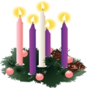

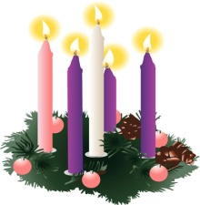

If you are interested in school admissions please speak to the welcomers who will register your attendance.

We cannot sign forms unless we have a record of your attendance.

A weekly **children’s sheet** is also available at the door. Please take one if you have someone you would like to pass it on to.

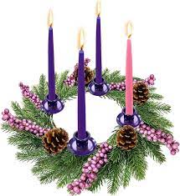

**CHRIST CHURCH**

**Milton next Gravesend**

*a faithfull welcome for all*

**www.christchurchgravesend.org.uk**

Vicar: The Revd Dr Andrew Davey

[vicar@christchurchgravesend.com](mailto:vicar@christchurchgravesend.com)

01474 352643

**15th December 2024**

*Third Sunday of Advent*

8am Holy Communion

10am Parish Eucharist with God’s Gang (followed by refreshments)

**THIS MORNING’S HYMNS**

527 On Jordan’s bank

99 Christ is the world’s light

690 Thy kingdom come on bended knee

83 Bread of the world

SHEET Earth was waiting

929 In the Lord

438 Make way make way

**Wednesday 18th December**

10am Holy Communion

5pm Evening Prayer

**Next Sunday 22nd December**

**Fourth Sunday of Advent**

8am Holy Communion

10am Parish Eucharist (followed by refreshments)

**MORNING PRAYER Join us in church or on zoom at 8.30am on Thursday and Friday**

[**https://us02web.zoom.us/j/82117921556**](https://us02web.zoom.us/j/82117921556)

**Please pray for**

Victims and survivors of abuse

The leadership of the Church of England

Our safeguarding team in the parish and diocese

All those who will come to our church in the coming weeks

Those affected by extreme weather

The people of Palestine, Israel and Lebanon, Syria, Ukraine and Russia, Darfur – for the United Nations

The people and churches of Jerusalem

Our preschool

Please remember those who have died recently, especially ,June Lacey, Ray Green and those who mourn.