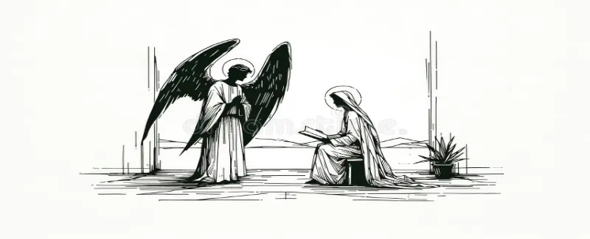Thank you to all who helped with the Whitehill School visit on Thursday.

**Last Saturday’s carol singing raised £648 for Christian Aid**

**This evening**

6pm Service of lessons and carols

**Tuesday 24th December**

3pm and 5pm Crib service

11pm Midnight Mass

**Wednesday 25th December**

8am Holy Communion

10am Christmas Eucharist with Carols

**New Year’s Eve Party**

To give us an idea of numbers, If you are hoping to come to the party, please sign the sheet at the back of the church.

The hall will be open from 8.30 pm.    Cost is £10 for adults. This includes party food and entertainment.

Please bring your own drinks.   This will be a fun evening so please come and join us.

**Saturday 18th January Beetle, Bingo, Fish and Chips**

Please arrive at 7 pm, food will be delivered at 7.30.

Please book with Angela on 07900430002, leave a message with your name, phone number and whether you would like fish or sausage.

**Still collecting**

**Items for the Food Bank and Daytime Hub**

**The items required are:**

Tins of meatballs, soup, fish, curry, sausages and beans, corned beef, spaghetti hoops

Packets of pasta long life milk

Pumpkin seeds Protein bars and fibre bars

Chocolates but not selection boxes Crisps

Shampoo, Conditioners, Deodorants

Pants and Boxer Shorts

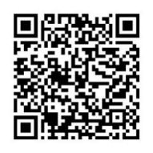Remember in addition to the collection

plate you can give to the Church using

the card reader or online you will find

our giving page using this QR code.

**CHRIST CHURCH**

**Milton next Gravesend**

*a faithfull welcome for all*

**www.christchurchgravesend.org.uk**

Vicar: The Revd Dr Andrew Davey

[vicar@christchurchgravesend.com](mailto:vicar@christchurchgravesend.com)

01474 352643

**22nd December 2024**

*Fourth Sunday of Advent*

8am Holy Communion

10am Parish Eucharist (followed by refreshments)

**THIS MORNING’S HYMNS**

631 Tell out my soul

634The angel Gabriel

605 Sing we of the blessed mother

259 Hail to the Lord’s anointed

182 For Mary mother

664 The saviour will come

406 Long ago

**Next Sunday 29th December**

**First Sunday of Christmas**

8am Holy Communion

10am Parish Eucharist (followed by refreshments)

**MORNING PRAYER Join us in church or on zoom at 8.30am on Monday and Tuesday**

[**https://us02web.zoom.us/j/82117921556**](https://us02web.zoom.us/j/82117921556)

**Please pray for**

Victims and survivors of abuse

The leadership of the Church of England

Our safeguarding team in the parish and diocese

All those who will come to our church in the coming week

The people of Palestine, Israel and Lebanon, Syria, Ukraine and Russia, Darfur – for the United Nations

The people and churches of Jerusalem

All who will find Christmas difficult

All who will be working over Christmas

Our friends at Larchwood

Please remember those who have died recently, especially ,June Lacey, Ray Green, Alison Glaisyer and those who mourn.

If you are interested in school admissions please speak to the welcomers who will register your attendance.

We cannot sign forms unless we have a record of your attendance.

A weekly **children’s sheet** is also available at the door. Please take one if you have someone you would like to pass it on to.