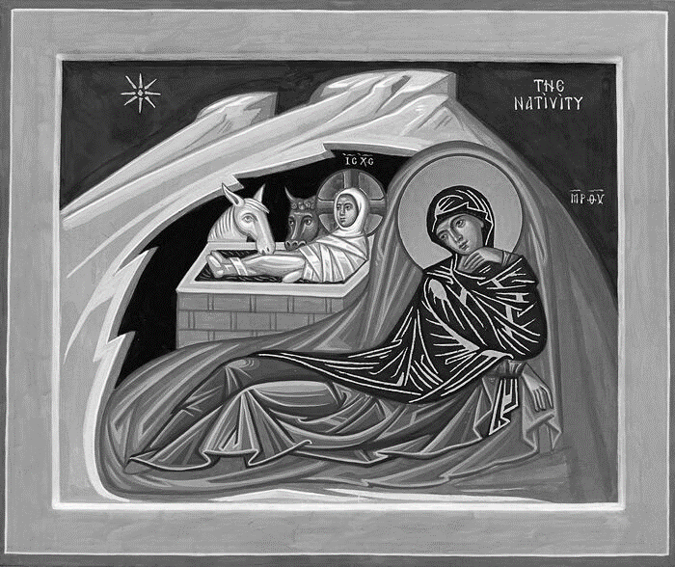

Much gratitude and thanks to all who contribute to looking after our beautiful church and to making our Christmas celebrations so special this year.

Thanks to everyone who contributed so generously to the Foodbank and Daytime Hub.

**New Year’s Eve Party**

To give us an idea of numbers, If you are hoping to come to the party, please sign the sheet at the back of the church.

The hall will be open from 8.30 pm.    Cost is £10 for adults. This includes party food and entertainment.

Please bring your own drinks.   This will be a fun evening so please come and join us.

**Saturday 18th January Beetle, Bingo, Fish and Chips**

Please arrive at 7 pm, food will be delivered at 7.30.

Please book with Angela on 07900430002, leave a message with your name, phone number and whether you would like fish or sausage.

Would you like to read or the lead the intercessions in church? Please speak to the Vicar.

Remember in addition to the collection

plate you can give to the Church using

the card reader or online you will find

our giving page using this QR code.

**CHRIST CHURCH**

**Milton next Gravesend**

*a faithfull welcome for all*

**www.christchurchgravesend.org.uk**

Vicar: The Revd Dr Andrew Davey

[vicar@christchurchgravesend.com](mailto:vicar@christchurchgravesend.com)

01474 352643

**29th December 2024**

*First Sunday of Christmas*

8am Holy Communion

10am Parish Eucharist (followed by refreshments)

**THIS MORNING’S HYMNS**

229 God rest you merry, gentlemen

4 A great and mighty wonder

536 O sing a song

860 Little Jesus sleep away

700 Unto us a boy is born

729 What child is this

243 Go tell it on the mountain

**Next Sunday 5th January**

**Epiphany**

8am Holy Communion

10am Parish Eucharist with God’s Gang (followed by refreshments)

**MORNING PRAYER will recommence on Monday 6th January**

**Please pray for**

Victims and survivors of abuse

The leadership of the Church of England

Our safeguarding team in the parish and diocese

All those have come to our church this week

Those affected by extreme weather

The people of Palestine, Israel and Lebanon, Syria, Ukraine and Russia, Darfur – for the United Nations

The people and churches of Jerusalem & Bethlehem

Those who live and work in care homes

Please remember those who have died recently, especially Ray Green and those who mourn.

If you are interested in school admissions please speak to the welcomers who will register your attendance.

We cannot sign forms unless we have a record of your attendance.

A weekly **children’s sheet** is also available at the door. Please take one if you have someone you would like to pass it on to.