Our collections at the Carol and Crib Services raised over £550 for Embrace the Middle East

**Wednesday 8th January**

2pm First Steps – all pre-schoolers welcome

**Thursday 9th January**

10 am Pilgrim Bible Study Genesis 11.1-9 The Tower of Babel

**Friday 10th January**

1.30pm Tots group in church hall

**Tuesday 14th January**

1.30pm Mothers’ Union First Aid with Louise

**Thursday 16th January**

2.30-4pm Mustard Seed

**Saturday 18th January**

9.30amworking party

Please come along and lend a hand.

**Saturday 18th January Beetle, Bingo, Fish and Chips**

Please arrive at 7 pm, food will be delivered at 7.30.

Please book with Angela on 07900430002, leave a message with your name, phone number and whether you would like fish or sausage.

Remember in addition to the collection

plate you can give to the Church using

the card reader or online you will find

our giving page using this QR code.

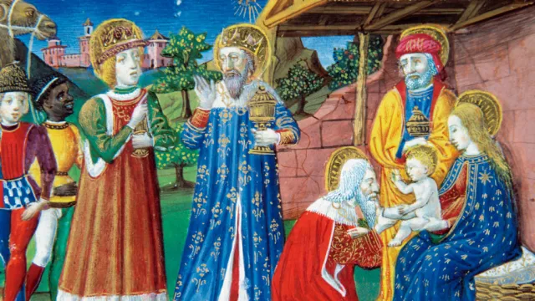

If you are interested in school admissions please speak to the welcomers, who will register your attendance.

We cannot sign forms unless we have a record of your attendance.

A weekly **children’s sheet** is also available at the door. Please take one if you have someone you would like to pass it on to.

**CHRIST CHURCH**

**Milton next Gravesend**

*a faithfull welcome for all*

**www.christchurchgravesend.org.uk**

Vicar: The Revd Dr Andrew Davey

[vicar@christchurchgravesend.com](mailto:vicar@christchurchgravesend.com)

01474 352643

**5th January 2025**

*The Epiphany*

8am Holy Communion

10am Parish Eucharist with God’s Gang

(followed by refreshments)

**THIS MORNING’S HYMNS**

49 As with gladness

724 We three kings

552 O worship the Lord

922 Adoramus te

729 What child is this?

85 Brightest and best

**Wednesday 8th January**

10am Holy Communion

5pm Evening Prayer

**Next Sunday 12th January**

**First Sunday of Epiphany : The Baptism of Christ**

8am Holy Communion

10am Parish Eucharist (followed by refreshments)

**MORNING PRAYER Join us in church or on zoom at 8.30am on Monday, Tuesday Thursday and Friday**

[**https://us02web.zoom.us/j/82117921556**](https://us02web.zoom.us/j/82117921556)

**Please pray for**

Victims and survivors of abuse

The leadership of the Church of England

Our safeguarding team in the parish and diocese

The people of Palestine, Israel and Lebanon, Syria, Ukraine and Russia, Darfur – for the United Nations

All affected by acts of violence

The people and churches of Jerusalem & Bethlehem

Those forced to flee their homes because of presecution

Those affected by extreme weather

Give thanks for our preschool, semi quavers, first steps and tots group.

Please remember those who have died recently and those who mourn.